Introduction to Caribbean Literature
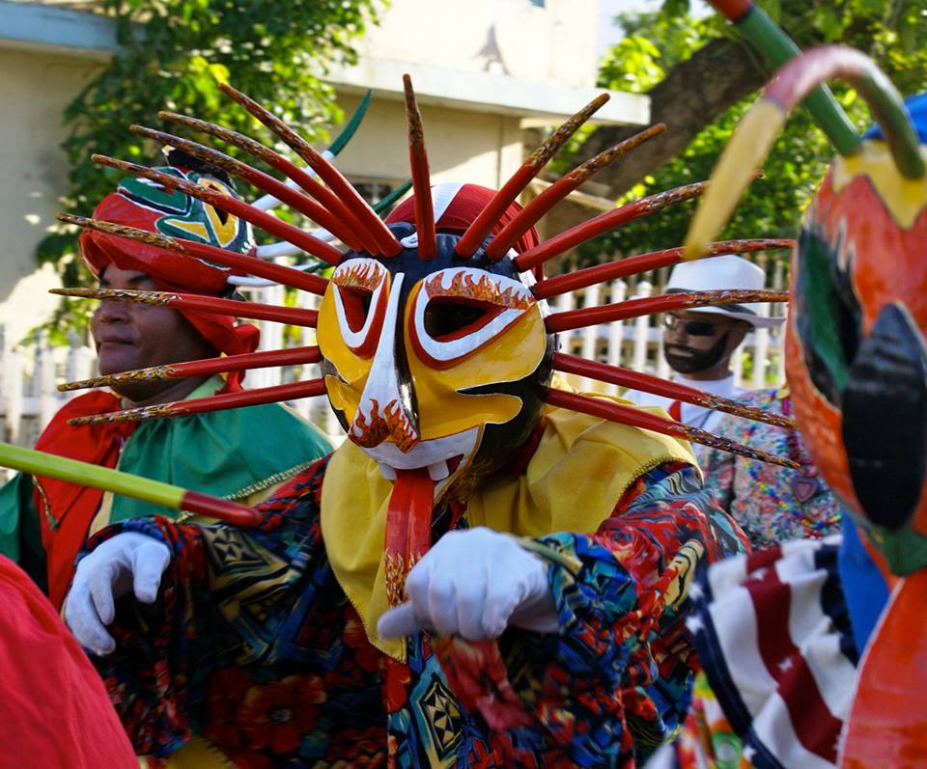

Course Convenor: Ms. Imen Chemengui
Level: 2nd year Students
Teacher: Ms. Imen Chemengui
Contact: e-mail, imenchmangui@yahoo.fr

(You should not expect a response during weekends. Please ensure that your email has a proper address and subject line as well as a proper signature.)

Course Description

The Caribbean, the islands of colliding cultures and mysteries, embraces diversity and cultural elements from Africa, India, Europe and North America. By virtue of its geography, its original inhabitants and the arrival of Europeans, the Caribbean is deemed the land of blended, hybrid cultures. However, despite such an inheritance, the history of the region is primarily tied to African slave-trade, colonialism and resistance. This course aims to get students acquainted with different literary movements that have emerged with the Caribbean as well as African and Caribbean writers who are hailed for covering a wide array of substantial themes and dominant problems that surface in the region such as slavery, black identity, sexuality, nation/narration, Diaspora, exile, race and gender, home, location/dislocation… This course aims at introducing students to the world of Caribbean literature through the reading of excerpts from different literary texts (Fiction and non-fiction texts), with the focus on the writer Jamaica Kincaid.

Course Objectives
Upon completion of the course, students will:
- Have known about different African and Caribbean writers and their works

- Have learned about relevant historical and cultural issues that have influenced literature and literary criticism in the Caribbean
- Have been able to read actively and react critically to some literary texts about the Caribbean
- Have learned how to write papers (critical reviews) about literary texts
Assessment
Oral presentations 30% (The list of topics will be shared with the students in due time)
Attendance and Participation in class activities 20%
Paper/Essay 20%
Test 30%

Course Calendar

Week One:
Introduction to the course
Week Two:
History of the Caribbean: History/ Music/ Geography (DVD)
(Class discussion)
Week 3-4
Introduction to Caribbean writers and their works, literary criticism..
Week 5-6-7-8
Analysis of Jamaica Kincaid: Lucy
Critical/ Active readings of excerpts from the novella
Week 9
Life and Debt (DVD) (by Jamaica Kincaid)
(Which addresses the impact of the International Monetary Fund, the World Bank, the Inter-American Development Bank and current globalization policies on a developing country such as Jamaica)

Class discussion of the documentary

Week 10:
Tutorial on how to write an Academic paper
MLA style
Week 11
DS
Week 12-13
Oral Presentations
Week 14
Correction of Students’ papers

►Plagiarism:
Plagiarism is stating other persons’ ideas, sentences without documenting them in your essay. It is highly recommended that students avoid plagiarism whether intentional or by mistake. Students will be penalized if they copy and paste other peoples’ words without including quotation marks. A guideline on how to avoid plagiarism will be given to students during the semester.

