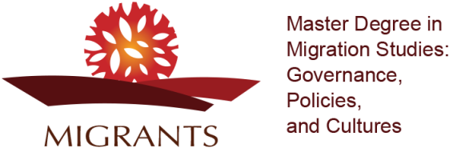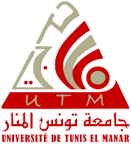

Higher Institute of Human Sciences(UTM)
Faculty of Human and Social Sciences (UT)
Faculty of Letters, Arts and Humanities of La Manouba (UMA)

Call for Applications for International Students
Research Master’s Degree
Migration Studies: Governance, Policies and Cultures
2021-2022

Objectives:
The Master’s in Migration Studies: Governance, Policies and Cultures is an international interdisciplinary, joint degree launched in the context of an Erasmus+ Higher Education Capacity Building Project MIGRANTS by the Higher Institute of Human Sciences of Tunis (UTM), the Faculty of Human and Social Sciences of Tunis (UT) and the Faculty of Letters, Arts and Humanities of La Manouba (UMA).The degree courses will be offered at the Higher Institute of Human Sciences of Tunis.
This degree in Migration Studies seeks to prepare students for research at the PhD level and for a professional career as specialists and experts within institutions and organisations – public and private, national and international – dealing with migration issues. The Master's programme will train students for a career in political institutions concerned with immigration and integration policies at the national and the international level. Graduates of Migration Studies will be suitable candidates for positions in governmental organisationsas policy analysts and policy advisors, in local and international NGOs and research institutes as consultants.
The Master’s Degree in Migration Studies: Governance, Policies and Cultures is offered in English for students from Tunisia, the Euro-Mediterranean Region and African countries
Eligibility:
Students holding a bachelor of arts (licence or a maîtrise) in the following disciplines: sociology, anthropology, psychology, philosophy, history, geography, geopolitics, law, economy and management, English, English and international relations.
Candidates who do not hold degrees with programmes taught in English have to provide an English Language certificate (TOEFL, IELTS, and TOEIC), level C1.
Repeaters are not eligible for this Master’s degree.
Number of Students:
The Master’s Degree in Migration Studies is open for 5 international students.
Application and pre-selection criteria:
Students are selected according to their academic files and an interview.
Applications have to be submitted online by Monday 18 October, 2021 at the following link: http://mastere.utm.rnu.tn/
International students are also required to submit their applications to the Ministry of Higher Education and Scientific Research (Direction Générale de la CoopérationInternationale) through diplomatic channels (Embassies).
Required documents
-Application form
-Certified copy of the degree (Licence or Maîtrise) or equivalent for foreign students
- Copy of transcript of records of all academic years
-A certified copy of the Baccalaureate or equivalent for foreign students
-Language certificate (TOEFL, IELTS, and TOEIC), C1
-Copy of passport
-Motivation letter in English
-CV
Students should send their documents directly to the following addresses:
Samira.mechri@issht.utm.tn
hboubaker@yahoo.fr
khaled.kchir@gmail.com

